Inheritance in Java

Java, Inheritance is an important pillar of OOP(Object-Oriented Programming). It is the mechanism in Java by which one class is allowed to inherit the features(fields and methods) of another class. In Java, Inheritance means creating new classes based on existing ones. A class that inherits from another class can reuse the methods and fields of that class. In addition, you can add new fields and methods to your current class as well.

Why Do We Need Java Inheritance?
- Code Reusability: The code written in the Superclass is common to all subclasses. Child classes can directly use the parent class code.
- Method Overriding: Method Overriding is achievable only through Inheritance. It is one of the ways by which Java achieves Run Time Polymorphism.
- Abstraction: The concept of abstract where we do not have to provide all details is achieved through inheritance. Abstraction only shows the functionality to the user.

Important Terminologies Used in Java Inheritance
- Class: Class is a set of objects which shares common characteristics/ behavior and common properties/ attributes. Class is not a real-world entity. It is just a template or blueprint or prototype from which objects are created.
- Super Class/Parent Class: The class whose features are inherited is known as a superclass(or a base class or a parent class).
- Sub Class/Child Class: The class that inherits the other class is known as a subclass(or a derived class, extended class, or child class). The subclass can add its own fields and methods in addition to the superclass fields and methods.
- Reusability: Inheritance supports the concept of “reusability”, i.e. when we want to create a new class and there is already a class that includes some of the code that we want, we can derive our new class from the existing class. By doing this, we are reusing the fields and methods of the existing class.

How to Use Inheritance in Java?
The extends keyword is used for inheritance in Java. Using the extends keyword indicates you are derived from an existing class. In other words, “extends” refers to increased functionality.
Syntax :
class derived-class extends base-class
{
//methods and fields
}

Inheritance in Java Example
Example: In the below example of inheritance, class Bicycle is a base class, class MountainBike is a derived class that extends the Bicycle class and class Test is a driver class to run the program.

class Vehicle
{
protected String brand = "Ford"; // Vehicle attribute
public void honk() { // Vehicle method
System.out.println("Tuut, tuut!");
}
}

class Car extends Vehicle {
private String modelName = "Mustang"; // Car attribute
public static void main(String[] args) {

// Create a myCar object
Car myCar = new Car();

// Call the honk() method (from the Vehicle class) on the myCar object
myCar.honk();

// Display the value of the brand attribute (from the Vehicle class) and the value of the modelName from the Car class
System.out.println(myCar.brand + " " + myCar.modelName);
}
}
Output

/ Java Program to illustrate Inheritance (concise)

import java.io.*;

// Base or Super Class
class Employee {
int salary = 60000;
}

// Inherited or Sub Class
class Engineer extends Employee {
int benefits = 10000;
}

// Driver Class
class Gfg {
public static void main(String args[])
{
Engineer E1 = new Engineer();
System.out.println("Salary : " + E1.salary
+ "\nBenefits : " + E1.benefits);
}
}

Output
Salary : 60000
Benefits : 10000
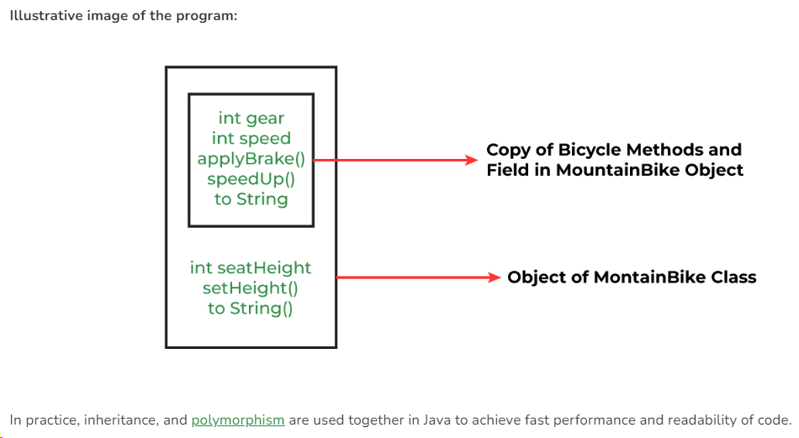

Java Inheritance Types
Below are the different types of inheritance which are supported by Java.
- Single Inheritance
- Multilevel Inheritance
- Hierarchical Inheritance
- Multiple Inheritance
- Hybrid Inheritance

1. Single Inheritance
In single inheritance, subclasses inherit the features of one superclass. In the image below, class A serves as a base class for the derived class B.
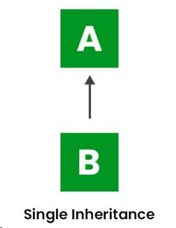
import java.io.*;
import java.lang.*;
import java.util.*;

// Parent class
class One {
public void print_geek()
{
System.out.println("Geeks");
}
}

class Two extends One {
public void print_for() { System.out.println("for"); }
}

// Driver class
public class Main {
// Main function
public static void main(String[] args)
{
Two g = new Two();
g.print_geek();
g.print_for();
g.print_geek();
}
}
Output
Geeks
for
Geeks

2. Multilevel Inheritance
In Multilevel Inheritance, a derived class will be inheriting a base class, and as well as the derived class also acts as the base class for other classes. In the below image, class A serves as a base class for the derived class B, which in turn serves as a base class for the derived class C. In Java, a class cannot directly access the grandparent’s members.

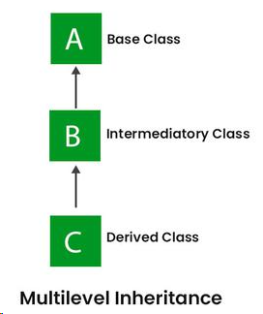
import java.io.*;  import java.lang.*;  import java.util.*;  class One {  public void print_geek()  {  System.out.println("Geeks");  }  }  class Two extends One {  public void print_for() { System.out.println("for"); }  }  class Three extends Two {  public void print_geek()  {  System.out.println("Geeks");  }  } | // Drived class  public class Main {  public static void main(String[] args)  {  Three g = new Three();  g.print_geek();  g.print_for();  g.print_geek();  }  }
Output
Geeks
for
Geeks

3. Hierarchical Inheritance
In Hierarchical Inheritance, one class serves as a superclass (base class) for more than one subclass. In the below image, class A serves as a base class for the derived classes B, C, and D.

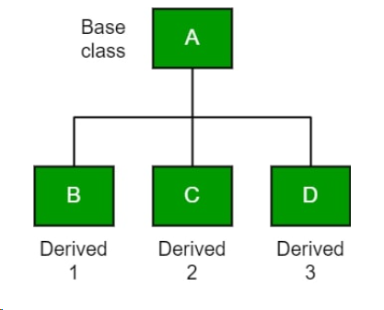

class A {  public void print_A() { System.out.println("Class A"); }  }  class B extends A {  public void print_B() { System.out.println("Class B"); }  }  class C extends A {  public void print_C() { System.out.println("Class C"); }  }  class D extends A {  public void print_D() { System.out.println("Class D"); }  } | // Driver Class  public class Test {  public static void main(String[] args)  {  B obj_B = new B();  obj_B.print_A();  obj_B.print_B();  C obj_C = new C();  obj_C.print_A();  obj_C.print_C();  D obj_D = new D();  obj_D.print_A();  obj_D.print_D();  }  }
Output
Class A
Class B
Class A
Class C
Class A
Class D

4. Multiple Inheritance (Through Interfaces)
In Multiple inheritances, one class can have more than one superclass and inherit features from all parent classes. Please note that Java does not support multiple inheritances with classes. In Java, we can achieve multiple inheritances only through Interfaces. In the image below, Class C is derived from interfaces A and B.

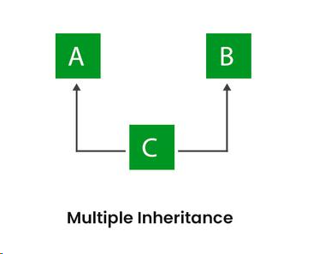
import java.io.*;  import java.lang.*;  import java.util.*;  interface One {  public void print_geek();  }  interface Two {  public void print_for();  }  interface Three extends One, Two {  public void print_geek();  }  class Child implements Three {  @Override public void print_geek()  {  System.out.println("Geeks");  } | public void print_for() { System.out.println("for"); }  }  // Drived class  public class Main {  public static void main(String[] args)  {  Child c = new Child();  c.print_geek();  c.print_for();  c.print_geek();  }  }
Output
Geeks
for
Geeks

5. Hybrid Inheritance
It is a mix of two or more of the above types of inheritance. Since Java doesn’t support multiple inheritances with classes, hybrid inheritance involving multiple inheritance is also not possible with classes. In Java, we can achieve hybrid inheritance only through Interfaces if we want to involve multiple inheritance to implement Hybrid inheritance.
However, it is important to note that Hybrid inheritance does not necessarily require the use of Multiple Inheritance exclusively. It can be achieved through a combination of Multilevel Inheritance and Hierarchical Inheritance with classes, Hierarchical and Single Inheritance with classes. Therefore, it is indeed possible to implement Hybrid inheritance using classes alone, without relying on multiple inheritance type.
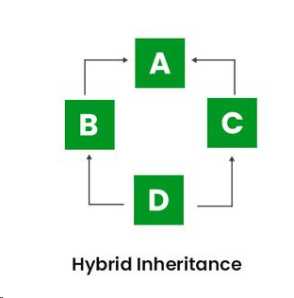

Java IS-A type of Relationship
IS-A is a way of saying: This object is a type of that object. Let us see how the extends keyword is used to achieve inheritance.

public class SolarSystem {
}
public class Earth extends SolarSystem {
}
public class Mars extends SolarSystem {
}
public class Moon extends Earth {
}

Now, based on the above example, in Object-Oriented terms, the following are true:-
- SolarSystem is the superclass of Earth class.
- SolarSystem is the superclass of Mars class.
- Earth and Mars are subclasses of SolarSystem class.
- Moon is the subclass of both Earth and SolarSystem classes.
class SolarSystem {  }  class Earth extends SolarSystem {  }  class Mars extends SolarSystem {  }  public class Moon extends Earth {  public static void main(String args[])  {  SolarSystem s = new SolarSystem();  Earth e = new Earth();  Mars m = new Mars();  System.out.println(s instanceof SolarSystem);  System.out.println(e instanceof Earth);  System.out.println(m instanceof SolarSystem);  }  } | Output  true  true  true

Advantages Of Inheritance in Java:
- Code Reusability: Inheritance allows for code reuse and reduces the amount of code that needs to be written. The subclass can reuse the properties and methods of the superclass, reducing duplication of code.
- Abstraction: Inheritance allows for the creation of abstract classes that define a common interface for a group of related classes. This promotes abstraction and encapsulation, making the code easier to maintain and extend.
- Class Hierarchy: Inheritance allows for the creation of a class hierarchy, which can be used to model real-world objects and their relationships.
- Polymorphism: Inheritance allows for polymorphism, which is the ability of an object to take on multiple forms. Subclasses can override the methods of the superclass, which allows them to change their behavior in different ways.

Disadvantages of Inheritance in Java:
- Complexity: Inheritance can make the code more complex and harder to understand. This is especially true if the inheritance hierarchy is deep or if multiple inheritances is used.
- Tight Coupling: Inheritance creates a tight coupling between the superclass and subclass, making it difficult to make changes to the superclass without affecting the subclass.

Abstract class in Java
A class which is declared with the abstract keyword is known as an abstract class in Java. It can have abstract and non-abstract methods (method with the body).

Abstraction in Java
Abstraction is a process of hiding the implementation details and showing only functionality to the user.
Another way, it shows only essential things to the user and hides the internal details, for example, sending SMS where you type the text and send the message. You don't know the internal processing about the message delivery.
Abstraction lets you focus on what the object does instead of how it does it.

Ways to achieve Abstraction
There are two ways to achieve abstraction in java
- Abstract class (0 to 100%)
- Interface (100%)

Abstract class in Java
A class which is declared as abstract is known as an abstract class. It can have abstract and non-abstract methods. It needs to be extended and its method implemented. It cannot be instantiated.
Abstract class: is a restricted class that cannot be used to create objects (to access it, it must be inherited from another class)

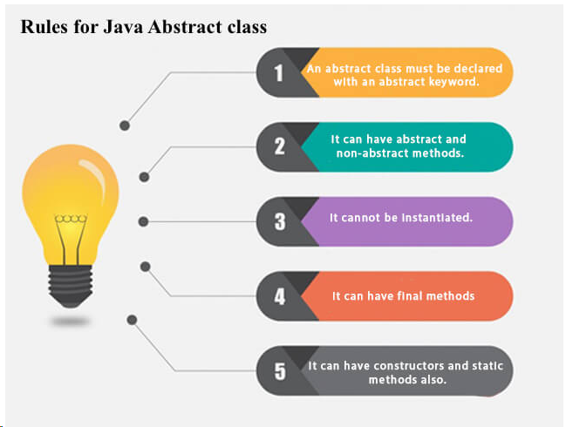
Example of abstract class
abstract class A{ }

Abstract Method in Java
A method which is declared as abstract and does not have implementation is known as an abstract method.

Example of abstract method
abstract void printStatus();//no method body and abstract

abstract class Bike
{
abstract void run( );
}
class Honda4 extends Bike
{
void run( )
{ System.out.println("running safely");
}
public static void main(String args[ ])
{
Bike obj = new Honda4( );
obj.run( );
}
}
running safely

Understanding the real scenario of Abstract class
In this example, Shape is the abstract class, and its implementation is provided by the Rectangle and Circle classes.
Mostly, we don't know about the implementation class (which is hidden to the end user), and an object of the implementation class is provided by the factory method.
A factory method is a method that returns the instance of the class. We will learn about the factory method later.
In this example, if you create the instance of Rectangle class, draw( ) method of Rectangle class will be invoked.

- abstract class Shape
- {
- abstract void draw( );
- }
- //In real scenario, implementation is provided by others i.e. unknown by end user
- class Rectangle extends Shape{
- void draw( )
- {System.out.println("drawing rectangle");}
- }
- class Circle1 extends Shape
- {
- void draw( )
- {System.out.println("drawing circle");}
- }
- //In real scenario, method is called by programmer or user
- class TestAbstraction1{
- public static void main(String args[ ])
- {
- Shape s=new Circle1( );//In a real scenario, object is provided through method,
- e.g., getShape( ) method
- s.draw();
- }
- }

drawing circle

Another example of Abstract class in java
abstract class Bank
{
abstract int getRateOfInterest( );
}
class SBI extends Bank
{
int getRateOfInterest( )
{return 7;}
}
class PNB extends Bank
{
int getRateOfInterest( )
{return 8;}
}

class TestBank
{
public static void main(String args[ ])
{
Bank b;
b=new SBI( );
System.out.println("Rate of Interest is: "+b.getRateOfInterest()+" %");
b=new PNB( );
System.out.println("Rate of Interest is: "+b.getRateOfInterest()+" %");
}}
Rate of Interest is: 7 %
Rate of Interest is: 8 %

abstract class Bike{
Bike(){System.out.println("bike is created");}
abstract void run();
void changeGear(){System.out.println("gear changed");}
}
//Creating a Child class which inherits Abstract class
class Honda extends Bike{
void run(){System.out.println("running safely..");}
}
//Creating a Test class which calls abstract and non-abstract methods
class TestAbstraction2{
public static void main(String args[]){
Bike obj = new Honda();
obj.run();
obj.changeGear();
}
}

bike is created
running safely..
gear changed

Rule: If there is an abstract method in a class, that class must be abstract.
- class Bike12{
- abstract void run();
- }
compile time error

Rule: If you are extending an abstract class that has an abstract method, you must either provide the implementation of the method or make this class abstract.

